Actions for this week:
Write the ethics application, draft the proposal in advance, prepare for the first meeting with my supervisor, think about replacement datasets, and complete part of the preprocessing for the RealWorld dataset.

What did I do this week? Why did I do this?
- Looked for last semester’s demonstration videos on the ethics application process and completed the ethics application in advance (09.30).
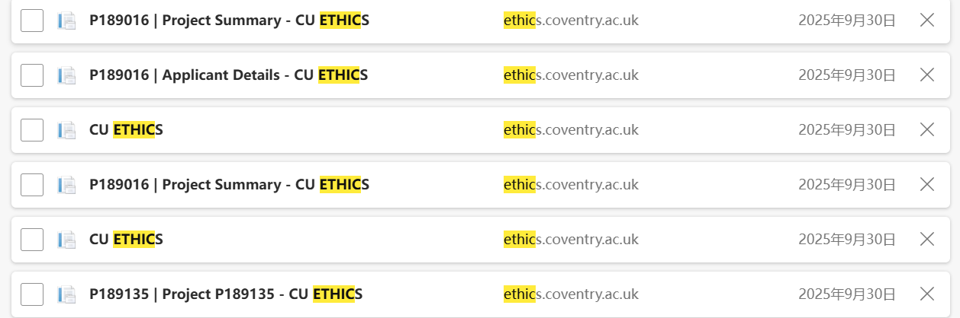

2. Checked the requirements for Coursework 1, started writing the proposal, and cross-checked whether I had actually answered the questions in Coursework 1 (09.30–10.02).

3. After reading through all three coursework briefs, I had some questions, so I prepared them in advance to ask during the first meeting with my supervisor.

4. My original plan was to use three datasets: RealWorld, PAMAP2 and WISDM. But after double-checking, I noticed this requirement in the Coursework 3 brief: “For this project you are not permitted to use datasets from Kaggle or the UCI Machine Learning Repository.” Since PAMAP2 and WISDM do not meet this requirement, I started to search for replacement datasets. I also found that some datasets, although not originally from Kaggle or the UCI ML Repository, have been mirrored onto Kaggle by others. So I emailed Dr Halloran to ask whether I am allowed to use such “Kaggle mirror” versions.
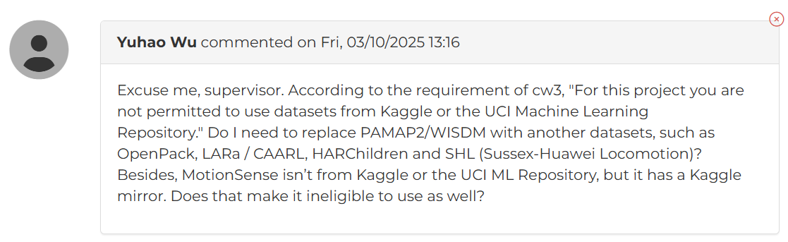
5. Wrote part of the preprocessing code for the RealWorld dataset.

Why:
1. For something relatively straightforward like the ethics application, which was already explained last semester, I should complete it independently and as early as possible. There is no need to bother my supervisor with this; I should reserve questions for the proposal. As it turned out, this was the right decision.

2–4. By preparing important tasks and questions early, I will have more time later to focus on running experiments.

Outcomes and findings:
1. After repeatedly watching last semester’s demonstration videos on the ethics process and carefully checking every question in the ethics form, I managed to complete the ethics application independently without asking my supervisor for extra help. This saved time and effort for both of us (10.03).

2. Finished the first draft of the proposal, emailed it to my supervisor, and asked two questions (10.02).
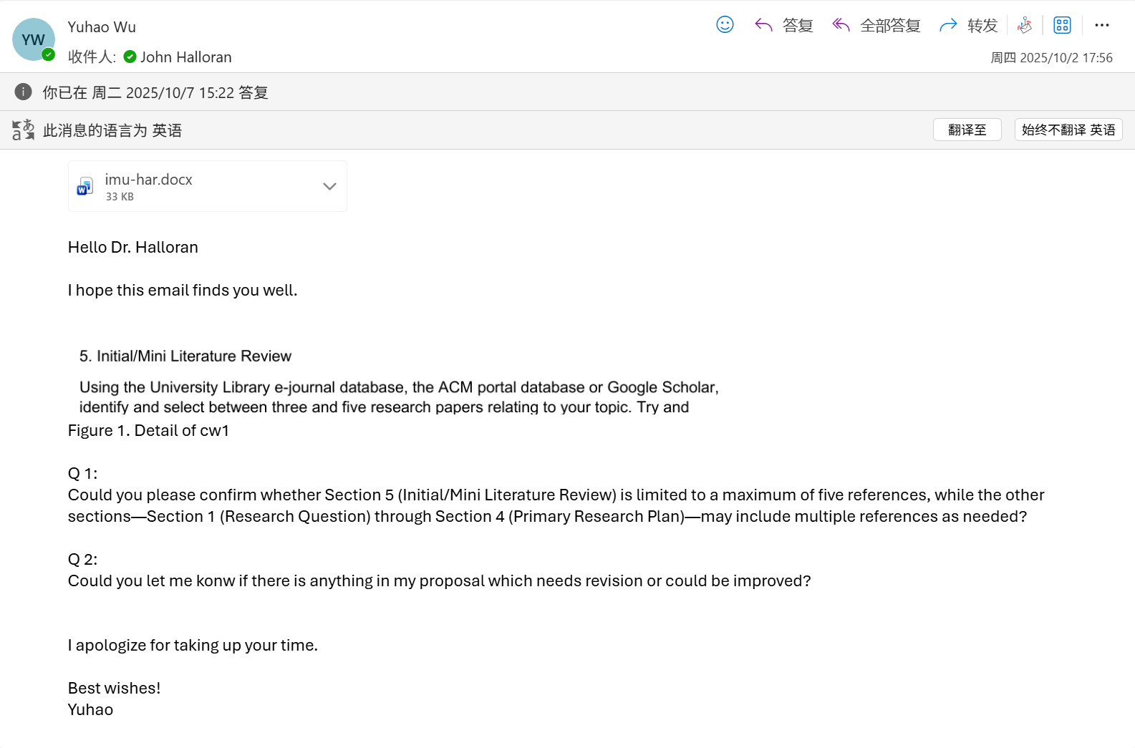
3. Prepared two questions to ask my supervisor in the meeting: one about the Q&A part of the presentation, and another about the literature review requirements in Coursework 3.

4. I am currently waiting for my supervisor’s reply on whether datasets that are not originally from Kaggle or the UCI ML Repository, but which have Kaggle mirror versions, are allowed.

5. Successfully completed part of the preprocessing code for the RealWorld dataset.

Reflection:
1. This was my first time writing an ethics application. Although I had carefully read the Coursework 3 requirements before, I failed to notice that datasets from Kaggle and the UCI ML Repository are not allowed. This was a careless oversight, and I need to be more careful in the future.

2. My supervisor has not replied to my email yet. I sent the proposal quite early, which was good, but the quality of my first draft was not ideal. Because I had already written a proposal last semester, I assumed there would not be another proposal assignment this semester, so I did not prepare in advance or look for excellent proposals in related areas as references. In hindsight, I could have asked some lecturers in the second semester about the exact structure of the third-semester project. This was a major oversight on my part. I should not always assume that my own guesses are correct; I need to reflect more often.

3. When I ask questions during a meeting, my supervisor’s responses are very detailed, which is much more efficient than asking by email. I can continue using this approach in the future.

4. I need to consider the worst-case scenario: that no matter where a dataset originally comes from, if it has ever appeared on Kaggle or the UCI ML Repository, then I cannot use it. As it turned out, thinking in this cautious way was correct.

5. Because I had already done preprocessing for the PAMAP2 dataset last semester, preprocessing the RealWorld dataset went much more smoothly this time.

Have I finished this week’s action? What percentage? If not, how to improve?
Completion rate: 85%.
There is still a remaining part of the RealWorld dataset preprocessing to complete.

Actions for next week:
Finish the remaining preprocessing for the RealWorld dataset, wait for my supervisor’s feedback on the proposal draft, and revise it accordingly.

Meeting part:
My discussion with my supervisor, John Halloran:

1. My supervisor, John Halloran, said he would like to use my ethics application as an example to show other students.
My reply: I agreed and was happy for him to do so.

2. I asked Dr John Halloran whether, in the Q&A part of the Coursework 2 presentation, we would be asked very difficult questions. I explained that there are thousands of possible questions in my research area, but my time is limited and I cannot study all of them in depth.
His reply: He told me not to worry too much about this. If I am asked something I do not understand, I can simply say, “Sorry, I do not know the answer to this, but I will look into it in the future.” He also mentioned that even when he was doing his PhD, there were still many things he did not understand.
My response/improvement: I will adjust my anxiety and not overthink this issue. For now, I will put this concern aside and focus on completing the proposal and the subsequent experiments. Once I become more familiar with my project and experiments, I will naturally be better able to answer questions in the presentation Q&A.

3. I asked Dr John Halloran whether, according to Part 5 (Literature Review) of the Coursework 1 brief, the entire proposal is only allowed to use at most five references.
His reply: He said that what we are writing now is a proposal, and there is no time to produce a full-scale literature review; a real, comprehensive review takes a lot of time. In his previous conference papers, he has used more than 20 references. However, using only five references in a proposal is far too few.
My response/improvement: I will add more references to my proposal.
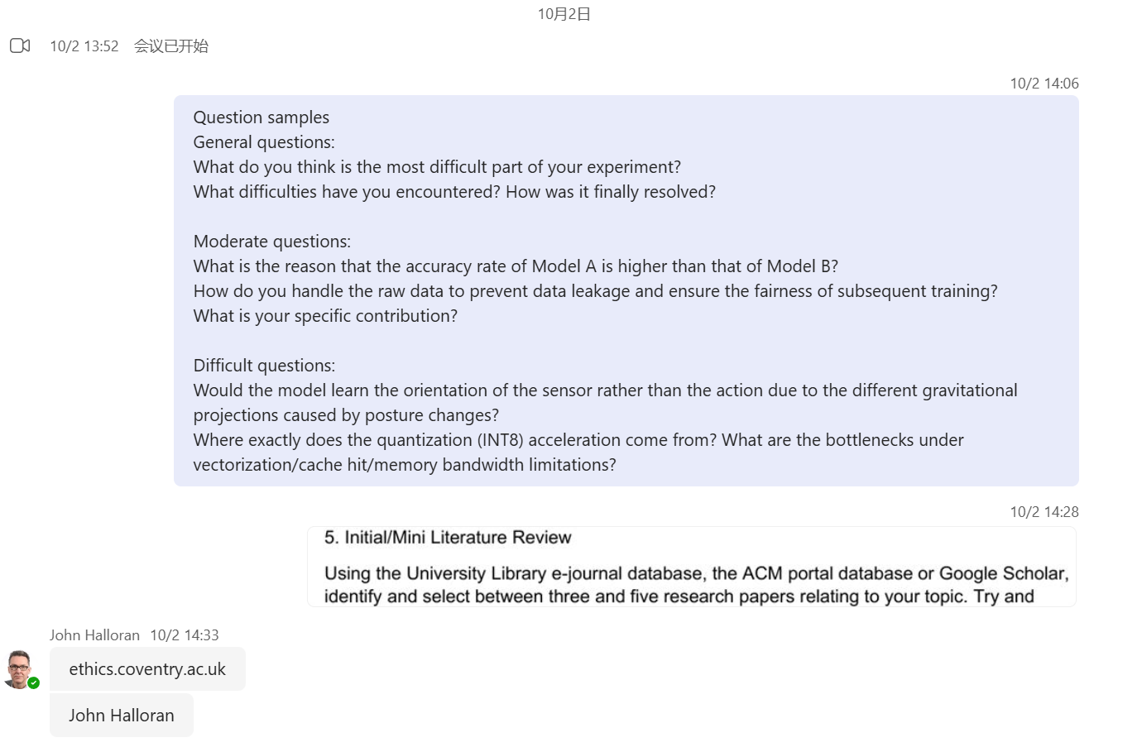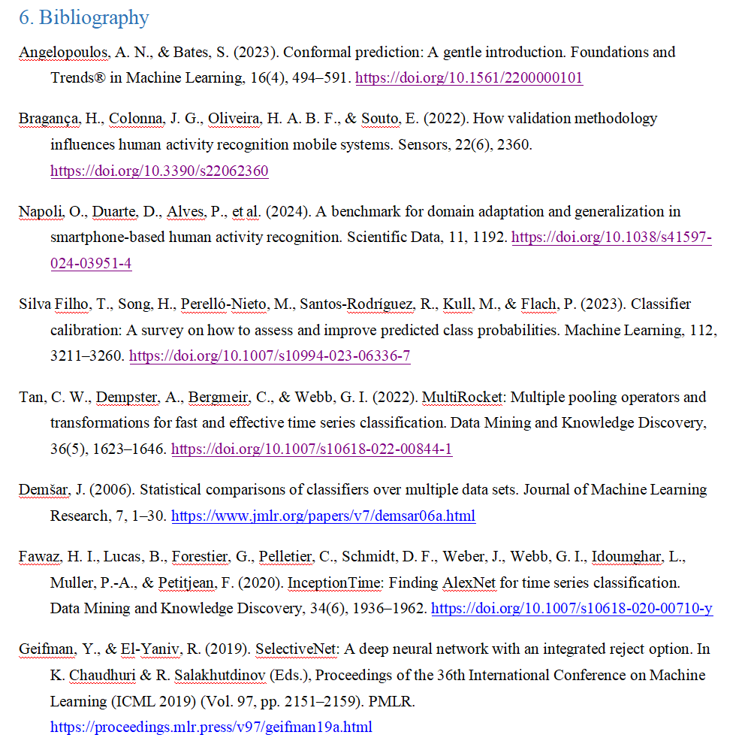

All important points my supervisor, John Halloran, has mentioned:

Module and supervision arrangement
Learning pace: This is a learning process. The module was originally planned for 12 weeks; there are currently about 10 weeks left. He will meet with us every week.
Supervision style: In the first half, supervision will be in small groups, then it will switch to individual supervision. After switching to one-to-one, the meeting time can be adjusted to something that suits both sides.
Questions and communication: Whenever we have questions, we can contact him via Teams or email, and he will reply.
Fixed meeting time: If this current time works for everyone, we can keep meeting at this time every week.

Assessment and deadlines (3 pieces of coursework)

CW1: Proposal (research plan)
Deadline: Monday, 13 October.
Content guidance: Research question, intended user group, system requirements, project deliverables and outputs, research plan, and an initial literature review.
Notes: We do not need to worry about the “Coventry API” part in the document. John Halloran is happy to give feedback once we have written a draft.

CW2: Presentation
Timing: Week 11.
Format: First, we upload the slides. Then, we will have about a 15-minute Teams session with John Halloran and a second marker, including a presentation and questions. John will help us prepare in advance and explain the process.

CW3: Dissertation
Weighting: This is the major assignment for this 60-credit module.
Timing: It typically starts in the second half of the module, or even later. John will provide substantial support.
Structure: There are requirements and guidance on report structure, appendices, formatting and ethics.
Marking scheme: There is a detailed marking rubric. Project process accounts for 40 percent.

“Project process” requirements (accounts for 40 percent)
Definition: In addition to the “product” (software/code, dissertation text), the process is also assessed rigorously.
Industry analogy: In industry, software is not produced without a good process. The process includes teamwork, knowing what you are doing, holding meetings and communicating effectively.

Evidence we need to provide:
• We can record Teams meetings and include links in our documentation as evidence.
• We should list, for each meeting, the topics discussed, the questions raised by John, and our responses.
• Every week, we should record our project work: what went smoothly, what did not, and which challenges we plan to bring back for discussion.

The goal is to show that we are working regularly, taking responsibility for our work, and that we have a clear path to success.

Literature review and references (for the proposal stage)
Goal: To explain the current state of the art in the field, what the problem space looks like, what experts have done/said, and which important questions remain unanswered.
Number of references: “Five is too few.” In professional research, the lower bound is around 20 references, and it is common to see 30–60 or more.
However, we are now only writing a proposal, not a full-scale literature review. What we need is a “starter” review: an overview of the main themes and the key views/approaches of experts.
Role: The literature review is used to show that we understand the existing problems in the field and how our research connects to and extends the work of experts.

For example, for wearable sensors used in HAR, we should cover:
• sensor types, application scenarios, the activities to be recognised and the purpose;
• and based on that, explain the positioning and additional contribution of our research.

Ethics system and process
System and creation: Log in to ethics.coventry.ac.uk and create an ethics proposal in the system. In the ethics form, list John as the supervisor.

Relationship to the proposal:
• In the proposal document, we only need to include our ethics application ID (example: P 189135).
• We do not need to have ethics approval granted before 13 October, but we must complete and submit the application by 13 October.
• If the ethics application is still being revised/updated when we submit the proposal, this does not affect proposal submission.

Submission timing suggestions: There is no need to submit ethics immediately. It is better to wait until the proposal is mostly formed, then complete the ethics form.

Review and outcome:
• When John reviews the ethics application, if more information is needed, he will give a “revise and resubmit” decision and clearly indicate what needs to be added; he will not simply reject it outright.
• John said that my ethics application looks fine and that he hopes to approve it by the end of the week. After approval, he will submit it, and I will receive the result by email.

Specific guidance for completing the ethics form (common for computing projects):
• External funding: No.
• Use of professional ethical codes: We can select “yes” (typically we follow the British Computer Society, BCS, Code of Conduct; if we choose “yes,” we must specify which code), or “no” – both are acceptable.

Data analysis–related items:
• Research involving terrorism or illegal activities: Always “no” (if “yes” is selected, the project cannot proceed).
• Use of secondary data: If we use online datasets, select “yes”; if we collect our own data, select “no.”
• Is the data publicly available: If it is from a repository or a public source, select “yes.”
• Can individuals be identified from the data: This must be “no”; all data should be anonymised.

• Use of primary data involving people: Usually “no.” If we do surveys or user studies, select “yes,” but then we must comply with GDPR and provide more detail. Even if human data is collected, it must be anonymised.
• Collecting data in languages other than English: Allowed, but it will trigger additional questions.

• Practice-based media/performing arts project: No (this does not apply to computing).

Other typically irrelevant items (not selected): fieldwork (e.g. anthropology), biological samples/physical measurements, biological materials/animals, hazardous chemicals, mechanical devices (other than computers), radiation, drones, environmental sampling, etc.

Interaction with human participants: This may be the only relevant section; if we select “yes,” we must provide detailed information, otherwise we will be asked to revise and resubmit.

Other points
• John will read our dissertation drafts at least once, possibly twice, and provide feedback. The goal is to support us through supervision and assessment so that we succeed.
• John will make sure we are prepared for the presentation and will explain the process and expectations.
• For the dissertation, both “product” and “process” matter: the written dissertation itself is a product, but the process is equally important (see the 40 percent project process weighting above).

